**ASSIGNMENT – 33.2**

**Problem Statement:**

* Integrate Hbase with Hive
* Load Data (Bulk Load) from Hive table to Hbase Table
* Explain the procedures and code implemented with screenshots. Note: Candidates should Load their own data into Hbase table.

**Solution:**

1. **Integrate Hbase with Hive**

**Create hbase table:**

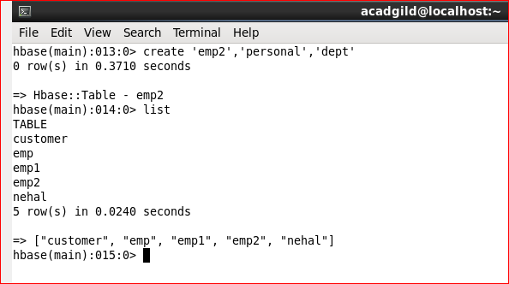

**Insert the data into HBase table:**

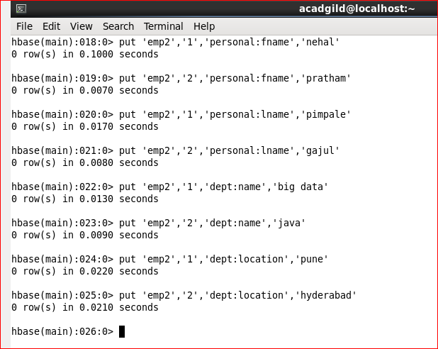

**Create the Hive table for each column family pointing to HBase table and displaying the contents of the hive table:**

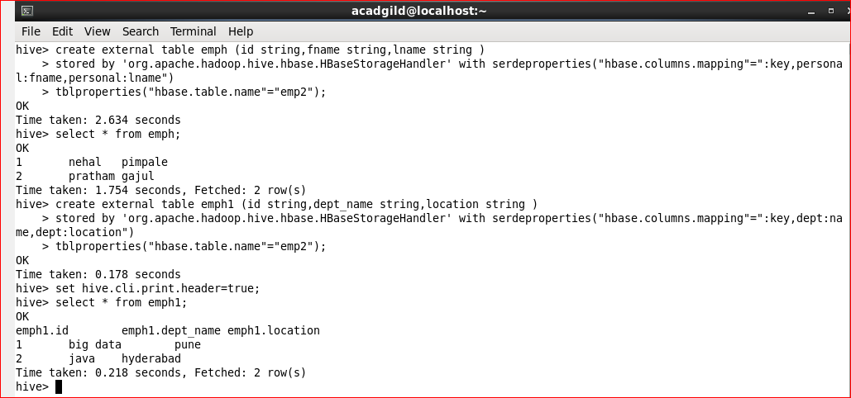

1. **Load Data (Bulk Load) from Hive table to Hbase Table:**

**Creating hbase table and scan the table(no data is loaded):**

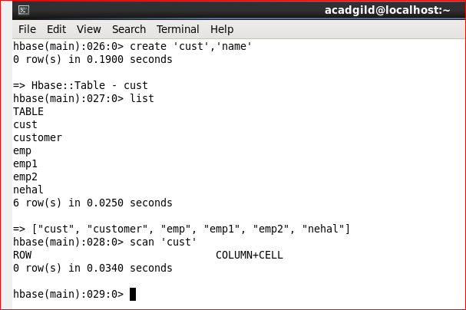

**Create table in hive and load the data and display the contents of the table:**

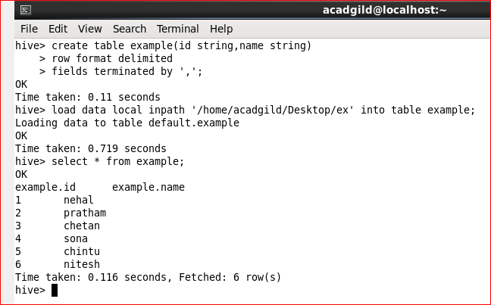

**Create external table and the loading the data from the above table:**

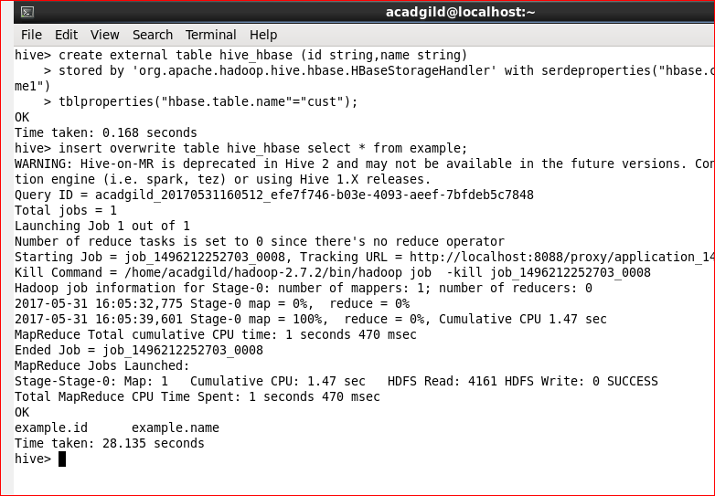

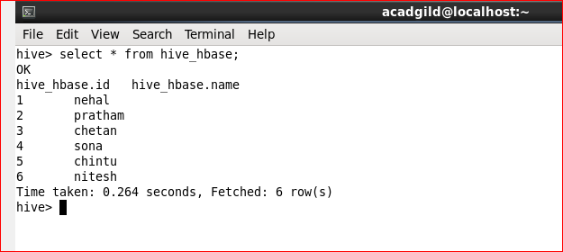

**Now scan the hbase table (data is loaded):**

